

KENYATTA UNIVERSITY
SCHOOL OF ENGINEERING AND TECHNOLOGY
DEPARTMENT OF MECHANICAL ENGINEERING
DESIGN OF A MANUALLY OPERATED WASHING MACHINE.

WILSON KANG’EE
J79/0628/2018
SHADRACH LEKUTIT
J79/0815/2018
NYABUTO N DOMINIC NYABUTO
J79/5662/2016

LECTURER: MS. JOYCE ACHENCHI
SUPERVISOR: DR. GEORGE MAGORE

DECLARATION

We hereby declare that this proposal is our own original work and has not been submitted before to any institution for assessment purposes. Further, we have acknowledged all sources used and have cited these in the reference section.

Name Reg. No Signature

Name Reg. No Signature

Name Reg. No Signature

This proposal has been submitted for examination with my approval as the University Supervisor.

Supervisor: Date:

TABLE OF CONTENTS
ABBREVIATION iv
ABSTRACT iv
LIST OF TABLES iv
LIST OF FIGURES iv
- INTRODUCTION 1
  - Background 1
  - Problem statement 1
  - Objectives 1
- LITERATURE REVIEW 1
- METHODOLOGY 1
  - Overview 1
  - Actual Design 1
3.3. Fabrication – Describe the practices that will be employed if any 1
- EXPECTED RESULTS 1
- WORK SCHEDULE 2
REFERENCES 3

LIST OF TABLES
Table 1 Materials of various elements 15
Table 2 Dimensions of various elements. 17
Table 3 Budget 21
Table 4 Work schedule 22

LIST OF FIGURES
Fig. 1 .Standard 3/32" multi-speed chain bicycle chain. 12
Fig. 2 .Chain, sprockets, and pedal assembly. 13
Fig. 3.Catcher and sprocket 13
Fig 4 . Perforated inner drum 14
Fig 5. Outer drum 15
Fig. 6. Frame and seat 18
Fig. 7:Full assembly in different views 19

ABSTRACT.
This research work deals with the design and fabrication of an improved cloth washing machine capable of small-scale industrial application as well as household use. The project is aimed at developing a washing machine that is efficient, affordable, durable, and compatible with rural areas with little or no supply of electricity.

Pedal Powered Washing Machine (PPWM) is a low-cost washing machine made up of easily and readily available scrap parts in daily life. It is a machine that generates power through human pedaling and with the drive mechanism, converts the pedaling motion into the required rotary motion of the drum. Its innovation lies in its simple design, use of inexpensive parts, very low repairing and maintenance cost, affordability to each member of society and it does not affect the environment. We intend to directly address the problems faced in washing clothes and thus have developed a new design that requires easy effort in washing and rinsing clothes. PPWM is a completely new concept, which in its one laundry cycle does washing and rinsing of clothes similar to that of an automatic washing machine available in the market.
The instruments, setup procedure, expected outcome, and budget in this research were all based on an actual design. The materials used in this research include a 100-liter plastic drum, 80-liter perforated plastic drum, a 78cm long 20mm-diameter solid shaft, two standard bicycle sprockets, chains, bearings, bicycle-like pedals, and metallic frames. Proper assembly and welding of the above raw materials will result in a simple and functioning pedal-powered washing machine. The research was conducted between the months of September, October, and November. The estimated cost of the model was Ksh.5250 which is subject to change depending on the size of the washing machine. The larger the machine the higher the cost of the materials required.

1.0 INTRODUCTION.
  - Background information.
The first manually operated washing machine was invented in the early 1800s by American inventor, Joel Henry Houghton. The machine was patented in 1845(Patel et al., 2013). The machine consisted of a large wooden tub that was filled with water and clothes. The user would sit on a seat and pedal a lever that turned a paddle inside the tub, which washed the clothes. In the early 1900s, pedal-powered washing machines were widely used in rural areas where there was no electricity. Machines were also used during the Great Depression when many people could not afford to buy an electric washing machine.
Manually operated washing machines continued to be used in some parts of the world until the 1970s when they were replaced by electric washing machines. These machines were simple and easy to use. It required no electricity and was very portable. The machine was also very affordable, which made it popular among rural families during the Great Depression. Despite the advantages of the pedal-powered washing machine, there were also some disadvantages. The machine was very slow and could only wash a small number of clothes at a time. The machine was also strenuous to use and required a lot of effort from the user (Patel et al., 2013)
Despite the disadvantages, the manual washing machine was an important invention that changed the way people washed their clothes. The machine was simple, affordable, and easy to use, which made it popular among families in the early 1900s.
Today, there are many different types of washing machines available on the market. Electric washing machines are the most common type of machine used in homes today. However, there are also many different types of pedal-powered washing machines available. These machines are still popular in some parts of the world where electricity is not readily available.
Modern washing machines use electricity in order to run the washing of garments. These machines typically use 400 to 1,400 watts of power; however, this amount greatly depends on the type that one uses. In Kenya, the electrification exercise has not covered a diverse area. According to recent research, rural electrification ranges between 40-45% (Mbohwa et al.,2017).

1.2 Problem statement.
Laundry is a day-to-day activity in every homestead. Most of the available washing machines may have a few challenges for the users. For instance, electric washing machines are not usable in areas with no electricity. Also, the cost, repair, and maintenance of the machine is very expensive and this discourages many people from purchasing the machine.
1.3Objectives.
General objective
- To design and fabricate a manually operated home washing machine.
Specific objectives
- To design parts of the manual washing machine using AutoCAD software.
- To fabricate various components of the machine.
- To assemble the parts, test the operation and conduct a cost analysis of a unit of the pedal-powered washing machine.
1.4 Justification
There are many advantages to using a manually operated washing machine over one powered by electricity. For one, pedal-powered washing machines are much more environmentally friendly. They do not rely on electricity to operate, which means that they produce no emissions.
Additionally, they are much more energy-efficient than traditional washing machines. Another advantage of manual washing machines is that they are much quieter than their electric counterparts. This is due to the fact that they do not have many moving parts. This means that they can be used in apartments and other places where the noise level is a concern.
Finally, manual washing machines are much cheaper to operate than electric ones. This is because they do not require any electricity to run. This means that users will not have to pay any electricity bills when they use the manual machine. Therefore, the several advantages of a manually operated washing machine over an automated one, give rise to the need of designing a pedal-powered washing machine.

2.0 LITERATURE REVIEW.
Innovative minds have always had entire humanity in their hearts and this often into spreading out innovation to effectively meet the needs of all putting into consideration the financial status and developmental access of different people. This has led to various designs of manually operated washing machines especially in rural areas with little or no electricity.
There are different types of manually operated washing machines. The Lavario portable clothes washer is a typical example of a manual washing machine. The machine uses a patented design that utilizes two counter-rotating drums to clean clothes. The user simply adds water and detergent to the machine, places the clothes inside, and then cranks the handle to start the washing cycle. The machine uses a combination of agitation and centrifugal force to clean clothes, and the user can control the amount of water and detergent used based on the type of clothing being washed. The machine can wash a load of laundry in about 15 minutes, and it can be used to wash both light and heavy-duty fabrics (Patel et al., 2013)).
A designed and fabricated Pedal Powered Washing Machine (Bhatawedekar et al., 2015) used a double speed altering pulley system with a pedal attached to a base entirely disconnected from the seat of the operator, the design makes can produce just two speeds depending on the input speed of the operator. it was ergonomically discomforting and had ambiguity in speed variation.
Another innovative design that entails a top-load washing drum and a pulley system to increase the input speed, the design whose cost of fabrication is $59, is considerably low lacks a seat for the operator, and is restricted to just a single pulley system there putting the responsibility of speed variation solely on the operator. (Tawanda Mushiri et al., 2017)
A designed and fabricated pedal-operated washing machine with the washing tub positioned behind the dynamo, with a maximum capacity of 2KG the machine speed is varied using a pulley system and a linear side motion accomplished using rack and pinion (Krishnamurthy M. et al., 2017). The position of the washing tub made it impossible for the operator to monitor the progress of the machine and limited to a single pulley system, variation of speed for the operations of laundry which include washing, rinsing, and spinning becomes the sole responsibility of the operator.
Another design sort to transform a scrap electric washing machine into a manually operated washing using pedal power coupled with a few gear system and rack-pinion system to turn the inner tub of the machine and also provide it with a back-and-forth movement the design is a little bit ambiguous and would require a little technical know-how for maintenance which may not be available at the rural area or intended target user.
Another common type of manual washing machine is the Wowku manual washer. The machine consists of a washing tub, a spin tub, and a wringer. The user first puts the clothes to be washed into the washing tub, which is filled with water and detergents. The user then uses the handle to agitate the clothes in the water for a period of time. After the clothes have been washed, the water is drained from the washing tub and the clothes are put into the spin tub. The spin tub is also filled with water, and the user uses the handle to agitate the clothes in the water. This causes the clothes to spin around and the water to be removed from the clothes. After the clothes have been spun, the user puts the clothes into the wringer. A wringer is a hand-powered machine that squeezes the water out of the clothes. The user then hangs the clothes to dry (Jani,2013).
The last type of manual washing machine is the portable manual washer.
The washer consists of a tub or basin, an agitator, and a hand crank. The user adds water and laundry detergent to the tub, then inserts the clothing to be washed. The agitator is then turned on, and the user cranks the handle to rotate the agitator and wash the clothing. To rinse the clothing, the user removes the agitator and cranks the handle in the opposite direction to spin the tub. This spins the clothing around in the tub and rinses the soap out of the fabric. The user then removes the clothing and hangs it up to dry (Rathwa et al.,2013).
The most common type of electric washing machine is the front-loading washing machine. This type of machine has a large cylinder that the laundry is placed into. Front-loading washing machines are the most efficient type of electric washing machine. This is because the clothes are washed in a small amount of water and the laundry is not exposed to the air for a long period of time. It can take up to an hour to wash a load of laundry in a Front-loading machine. There are several different designs of electric washing machines. The most common design is the front-loading washing machine (Pakula,2010). However, there are also top-loading and side-loading washing machines. The main difference between the different types of electric washing machines is the amount of laundry that they can wash at one time. Front-loading washing machines are the largest and can wash up to 12 pounds (5.4 kg) of laundry at a time.
Top-loading washing machines are smaller and can wash up to 5 pounds (2.3 kg) of laundry at a time. Side-loading washing machines are the smallest and can wash up to 3 pounds (1.4 kg) of laundry at a time. The size of the washing machine is not the only factor that determines the amount of laundry that it can wash at one time. The type of fabric that the clothes are made from will also affect the amount of laundry that the machine can wash. For example, a front-loading washing machine can wash more delicate fabrics than a top-loading washing machine. The capacity of an electric washing machine is usually measured in terms of the number of laundry items that it can wash at one time. The capacity of a machine is usually given in terms of the number of pounds (kg) of laundry that it can wash at one time. For example, a machine that has a capacity of 12 pounds (5.4 kg) can wash up to 12 pounds (5.4 kg) of laundry at a time. The capacity of an electric washing machine can be increased by adding an extra tub. An extra tub is a second cylinder that is attached to the first cylinder. The extra tub allows the machine to wash more laundry at one time (Kong et al., 2014).
Electric washing machines are typically made from metal or plastic. The body of the machine is usually made from metal. The tubs are usually made from plastic. The metal body of the machine is usually powder-coated to protect it from rust. The powder coating also makes the machine more durable. The plastic tubs are usually made from high-density polyethylene (HDPE). HDPE is a type of plastic that is very durable. It is also resistant to chemicals and does not absorb water.
In the above studies, several gaps exist and need to be fixed. Firstly, the manual machines as described are hand powered. These machines can only be used by specific people and the physically challenged such as those with no arms are limited from using the machine. Additionally, spinning the drums by hand is a labor-intensive and tiresome activity. This implies that only a few clothes can be washed at a time. ( Rathwa et al .,2019).
On the other hand, the electric machine is very expensive to purchase and maintain. It can only be used in areas with electricity and can’t be used in rural areas where there is no electricity, especially in Kenya.
Also, the electric machine uses electricity which means that users will have to pay electric bills each time they use the washing machine. Lastly, when there is a power breakdown, the whole laundry process stops since the machine is electrically powered hence it is not reliable.

3.0 MATERIALS AND METHODS.
3.1 MATERIALS.
3.1.1 SEAT
This is an arrangement in the machine upon which a person can sit comfortably while washing clothes. In seating arrangements, the design factor is always considered according to their use in any machine. Seats may be made of various materials. In this design, the seat will be made of metal.
3.1.2 PEDALS.
The pedal is the part of the machine that the rider pushes with their foot to propel the drum. It provides the connection between the cyclist's foot and the crank allowing the leg to turn the bottom bracket spindle and propel the inner drum. Pedals usually consist of a spindle that threads into the end of the crank and a body, on which the foot rests or is attached, that is free to rotate on bearings with respect to the spindle.
3.1.2 SPROCKETS.
Sprockets are the parts of the machine that are connected to the inner drum and the pedals. The sprocket that is connected to the inner drum is smaller in size and has a few teeth compared to the one connected to the pedals. When pedaling the large sprocket helps to convert the pedaling motion into linear motion. The standard bicycle sprockets are used in the design of the machine.
3.1.3 CHAIN.
The chain is used to connect the two sprockets and transmit power from the large sprocket to the smaller sprocket. In this, a standard 3/32" multi-speed chain will be used.
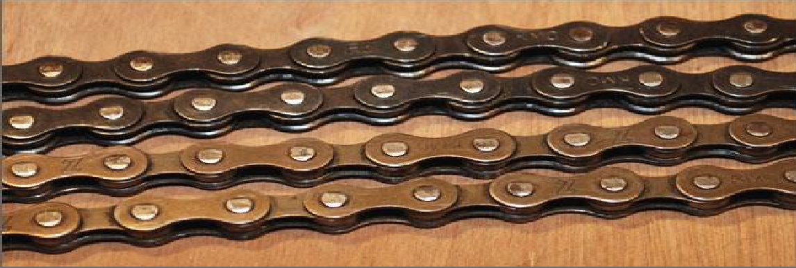
Figure 1:Standard 3/32" multi-speed chain bicycle chain.

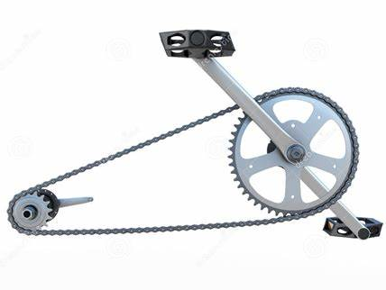
Figure 2:Chain, sprockets, and pedal assembly.

3.1.4 CATCHER.
The catcher is the part of the rickshaw on which the sprocket is mounted. It has threads and it is used to ensure the sprockets are held tightly.

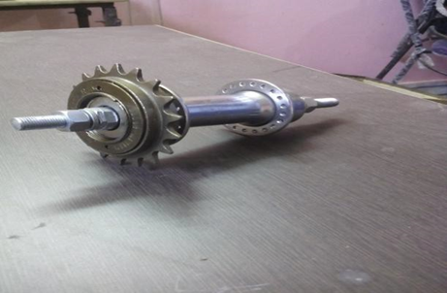
Figure 3:. Catcher and sprocket
.
3.1.5 SHAFT.
A shaft is a mechanical component used for transmitting torque and rotation, usually used to connect different machine elements that cannot be connected directly because of their distance from each other or the need to allow for relative movement between them.

3.1.6 DRUMS
Inner drum. This drum houses the clothes during washing. It is Smaller in diameter as compared to the outer drum. The inner drum is blanked throughout its body. It rotates with the help of a compound Shaft and chain arrangement at the desired speed with respect to the purpose. The drum also has an opening at the top to allow adding and removing clothes

Figure 4:Perforated inner drum
Outer drum.
The outer drum is made of plastic and is used to store water.

Figure 5:Outer drum

S/N | Component | Material | Process
1 | Outer drum | Poly ethylene
2 | Inner drum | Poly ethylene | Drilling
3 | Support frame | Cast iron/mild steel | Welding and grinding
4 | Roller chain | Mild steel
5 | sprockets | Mild steel
6 | Bearing | Mild steel
7 | Pedal set | Mild steel | Turning
Table 1. Materials of various elements
3.2 DESIGN ANALYSIS

Capacity:
Minimum 5kg of clothes/load

Water
Effective washing must occur in soft and hard water at temperatures from 27-50ºc

Water usage:
Maximum 5L water / .5kg clothes

Active pedaling time for effective washing
Maximum 20 minutes each for wash and rinse cycles
Total operation time:
Maximum 1 hour, including fetching water, filling, washing, draining, and cleaning the machine.

Power
Maximum 100W (comfortable level for a healthy human-power output)

Cost:
Ksh 3,500 (comparable to the cost of other washing machines)
Lifetime of structure
5 years, assuming daily use

Manufacturing location
Kenyatta university engineering workshop

Weight:
Maximum 10kg, or 25kg if it has wheels (1 woman can move it indoors so it can’t be stolen or damaged).
3.2.1 Design Calculations
SYSTEM OF FORCE AT THE PEDAL (Power input)
For effective calculation of forces and torque in the system; the following assumptions were made: Mass of the laundry man (m) – 50kg
Duration of pedaling (t) = 60mins = 3600s
Starting speed (Ns) – 60rpm
Crank lever length (Rc) = 170mm = 0.170m
Power generated by man during leg cranking = 125W
Angular velocity of the Driver sprocket (ωs) - 2𝜋𝑁 60………………………………. (1)
𝜔 = 6.28𝑟𝑎𝑑/𝑠
Torque delivered to the pedal during cranking 𝑇 = 𝑃/ 𝜔………………………………………… (2)
𝑇 = 19.9𝑁𝑚
Force delivered to the sprocket 𝐹𝑑 = 𝑇 𝑅𝑐 …………………………………………… (3)
𝑭 = 𝟏𝟏𝟕.𝟏𝑵
Force generated by pedal (Fg) = Force delivered during cranking (Fd)
Torque generated (T) = 𝐹𝑔 × 𝑅 ……………………………………………………… (4)
𝑻 = 𝟐𝟖.𝟒𝟐𝑵𝒎
Power generated by the driver sprocket (P) = 𝜔T …………………………………… (5)
𝑷𝒊𝒏 = 𝟏𝟕𝟖.𝟒𝟖 W

Power Output
𝜔𝐴 = 𝑠𝑝𝑒𝑒𝑑 𝑜𝑓 𝑑𝑟𝑖𝑣𝑒𝑟 sprocket
𝜔B = 𝑠𝑝𝑒𝑒𝑑 𝑜𝑓 𝑑𝑟𝑖𝑣𝑒n sprocket
T 𝐴 = 𝑁𝑢𝑚𝑏𝑒𝑟 𝑜𝑓 𝑡𝑜𝑜𝑡ℎ 𝑜𝑓 𝑡ℎ𝑒 𝑑𝑟𝑖𝑣𝑒𝑟 sprocket
T B= 𝑁𝑢𝑚𝑏𝑒𝑟 𝑜𝑓 𝑡𝑜𝑜𝑡ℎ 𝑜𝑓 𝑡ℎ𝑒 𝑑𝑟𝑖𝑣𝑒n sprocket
NA= speed of the driver sprocket
NB= speed of the driver sprocket
T1= torque on the driver sprocket
T2= torque on the driven sprocket
NA/NB=TB/TA
NA=60RPM
NB=(NA*TA)/TB
(60*48)/18…………………………………………………………………………. (6)
NB=160RPM.
𝜔B =(2$*π$*NB)/60
(2* $π$*160)/60……………………………………………………………………… (7)
𝜔B =16.755rads/sec
Pitch radius of the driver sprocket
=0.121m
T2= force delivered to the driven sprocket *pitch radius of the driven sprocket
117.1N*0.121m
T2= 14.21Nm……………………………………………………………………... (8)
Power output = T2* 𝜔B
14.21*16.755……………………………………………………………………… (9)
=238.09W
Efficiency of the machine
Efficiency= power input/power output
(178.48/238.09) =75%............................................................................................(10)
S.NO | PARAMETERS | DIMENSION (mm)
1. | Inner drum diameter | 400
2. | Outer drum diameter | 600
3. | Length of inner drum | 500
4. | Length of shaft | 780
5. | Height of base above the ground | 600
6. | Length of base | 740
7. | Width of base | 700
8. | Height of seat | 450
9. | Height of handle | 250
10. | Length of outer drum | 700

Table2.Dimensions of various elements.
3.3 Methods
The assembly of the machine involves a number of steps, these are stated from the frame of the cycle which is the initial part of the structure:
Step 1: First make the support frame and seat by welding
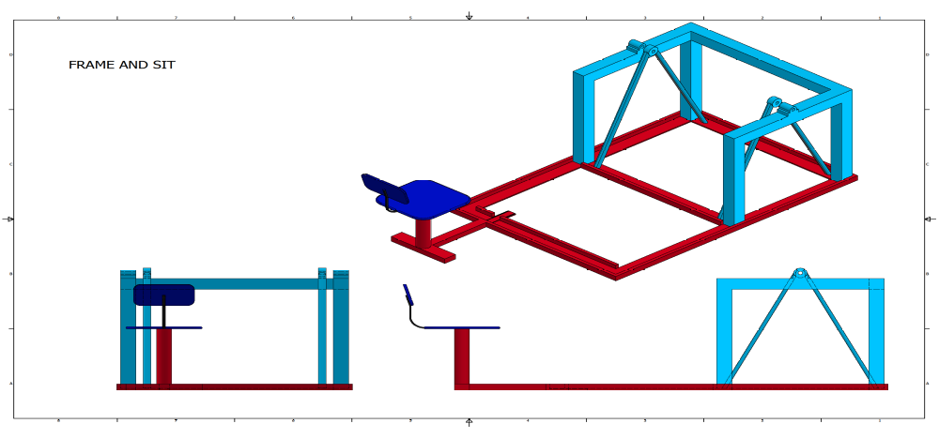
Figure 6:Frame and seat

Step 2: Cut the outer drum at one of its ends to form a passage for the inner drum. Cut out an opening on the top of the outer drum. Make two hinges on the top to facilitate the closing and opening of the drum. Make a hole on the end of the drum and insert a tap to facilitate the emptying of the drum.
Step 3: Fix the shaft with the perforated drum from one end to the other. Attach the bearings on either side of the shaft. Make a small opening at the top of the perforated drum. Make two hinges to facilitate the opening and closing of the drum. Place the perforated drum with the shaft inside the large drum.
Step 4: Place the assembly in the frame.
Step 5: Assemble the cycle frame which consists of the sprockets, catcher, chain, and, pedal to the support frame through welding.
Step 6: Connect the two sprockets with the help of a chain.
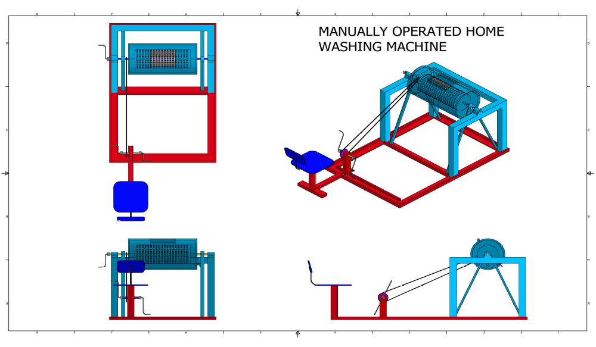
Figure 7:Full assembly in different views

3.4 Working Principle of the machine
The inside drum is filled with clothing, and the outside drum is filled halfway with water. The water in the outer drum is mixed with laundry detergents. When the laundry person presses the pedals with their feet, the machine begins to operate.
The motion is conveyed through the roller chain to the smaller sprocket, which then turns the shaft fixed with the inner drum. Water agitates and rubs against the clothing while the inner drum rotates, cleaning it.

4.0 EXPECTED RESULTS.
The machine would allow women to wash clothes faster and with less strain. In families where children have to do laundry themselves, the machine will help to save time for the children and hence, they can concentrate fully on their studies. Women can spend time engaging in some income-generating activities. A company for selling the machines may arise as a result if the machine is accepted in society.
We expect most people to purchase the machine because it is cheap and easy to maintain as compared to its electrical counterparts. We also expect to reduce the problem of back pains for people who experience the pains when they do laundry by hand. The physically handicapped will also be able to do laundry themselves without any assistance.
The knowledge of our research will greatly contribute to society in a positive way. This is because many labor-intensive activities are carried out by hand examples include: lifting water from a well, winnowing, and, wood cutting. Most of these activities can be carried out using a pedal-powered machine.
4.1 Results impact on future research.
With the help of this Pedal-powered washing machine, there are a number of other technologies that can be developed such as.
Operating a woodworking lathe: The pedaling motion can be used to rotate the wooden workpiece the tool moved along the rotating wood to cut it. In villages without electricity, small workshops can be run with this low-cost machine. It does not require any electricity, so it is a one-time investment.
Pumping water from a shallow well. A pedal-powered machine can also be developed for use in pumping water from a shallow well. The water is pumped to the ground with the help of pedaling motion. This machine can be used by anyone i.e., men, women, children etc., and does not require electricity to run.
Operating a circular saw. Since the modern saw uses circular motion to cut wood, it is only limited to areas with electricity. A pedal powered machine can be used to rotate the cutting tool and hence used to cut the wood fed against it.
5.0 BUDGET.

S. NO. | NAME OF THE COMPONENT | QUANTITY | ESTIMATED (KSH)
1. | Drum | 2 | 1000
2. | Sprockets and Catcher | 1 | 1000
3. | bearings | 2 | 1000
4. | Pedal set | 1 | 500
5. | Roller Chain | 1 | 500
6. | Paint | 1L | 250
7. | Overhead |  | 1000
8. | Total cost |  | 5250
Table 3. Budget.

6.0 WO|RK SCHEDULE
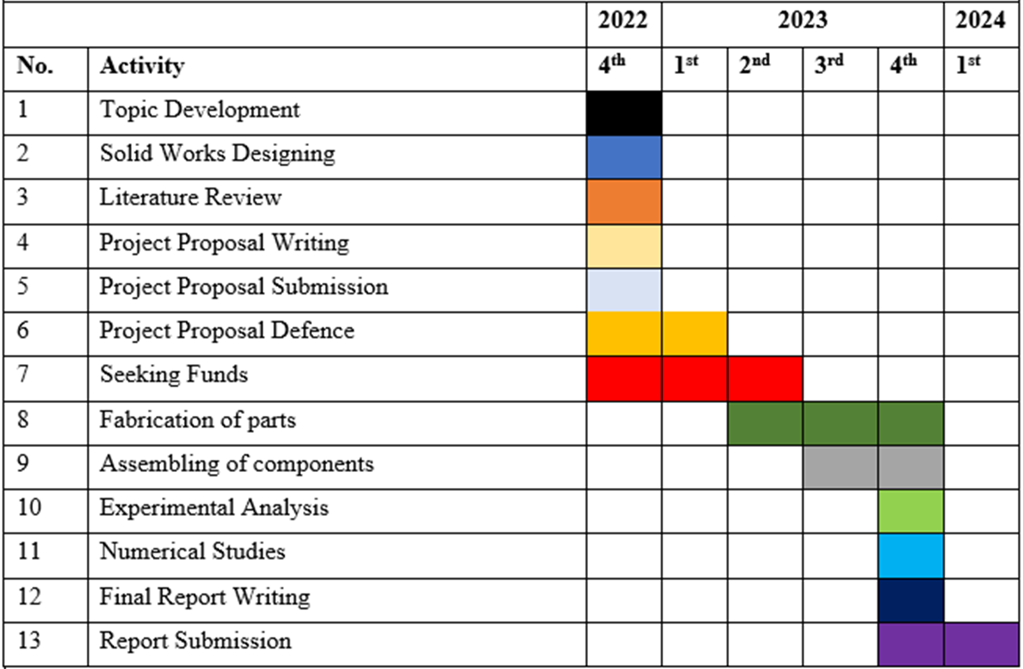
Table 4. Work Schedule.

7.0 REFERENCES.
- EYERE, E., OLABISI, A. I., & ARUOTURE, O. P. (2017). DESIGN AND DEVELOPMENT OF A LOW-COST WASHING MACHINE SUITABLE FOR POLYTHENE MATERIALS. Asian Journal of Current Research, 2(1), 22-32.
- Ali, A., Yadav, K. S., & Yadav, A. (2019). Mechanical washing machine. International Journal of Research in Engineering, Science and Management, 2(6), 76-80.
- Moghe, S. M., & Zakiuddin, K. S. (2013, December). Design and development of turmeric polishing machine energized by human power flywheel motor—a past review. In 1st international and 16th national conference on machines and mechanisms, Inacom (pp. 920-923).
- BHUSHANAM, P. C., & GOPICHAND, D. (2020). MANUFACTURING OF HUMAN POWERED OPERATED WASHING MACHINE.
- Patel, N. R., Vasanwala, M. A., Jani, B. B., Rathwa, M. D., & Thakkar, R. A. (2013). Material selection and testing of hacksaw blade based on mechanical properties. International Journal of Innovative Research in Science, Engineering and Technology, 2(6).
- Ajay, R. S., & Choudhary, S. K. Design & Fabrication of Manually Driven Pedal Powered Washing Machine.
- Mushiri, T., Mugova, T. J., & Mbohwa, C. (2017, October). Design and fabrication of a pedal powered washing machine. In Proceedings of the International Conference on Industrial Engineering and Operations Management Bogota, Colombia (pp. 355-366).
- Swarnakiran, S. (2017). Design & fabrication of horizontal drum pedal powered washing machine. ATMECE.
- Mogaji, P. B., Jayeola, H. O., & Echoga, D. A. (2020). DEVELOPMENT OF AN IMPROVED PEDAL POWERED WASHING MACHINE. AU eJournal of Interdisciplinary Research (ISSN: 2408-1906), 5(2).
- Popoola, E. O., & Aribiegbe, K. G. (2021). Design and Fabrication of a Physiotherapy Manually Driven Washing Machine.
- Haris, O., & Darmawan, A. (2020). Design and Analysis of Application of CVT (Continously Variable transmition) On Activator Washing Machine Mechanic Maximum Capacity 7kg. INTERNATIONAL JOURNAL ENGINEERING AND APPLIED TECHNOLOGY (IJEAT), 3(2), 67-74.
- Ajay, R. S., & Choudhary, S. K. Design & Fabrication of Manually Driven Pedal Powered Washing Machine.
- Kilincci, O., & Onal, S. A. (2011). Fuzzy AHP approach for supplier selection in a washing machine company. Expert systems with Applications, 38(8), 9656-9664.

